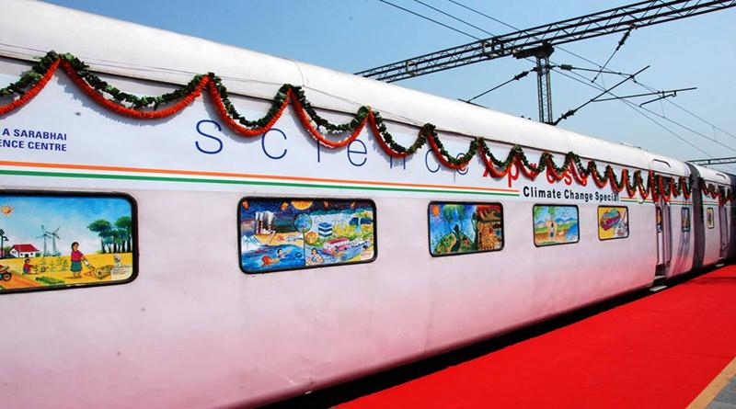
SCIENCE EXPRESS- CREATING CLIMATE CONSCIOUSNESS
On 19th July, the class of TYBMM Journalism was informed that we would be visiting the ‘Science Express Climate Action Special’, a 16-coach AC train aiming to create climate change awareness in India which had rolled into CST station for 4 days from 19th-22nd July between 10 am-5 pm, the next day. Excited, we assembled at CST on 20th July with our HOD Vaneeta Raney at 1 pm only to be greeted by a huge queue of kids to adults.
After a harrowing 3 hour wait in the queue made better by chatter and pictures, we finally made it to the doors of the Science Express. Once inside, the first model was Mother Earth with a thermometer, saying she has ‘fever.’ This signified how hot the earth had become due to global warming. We would soon see how each coach covered elaborate themes on global climate.
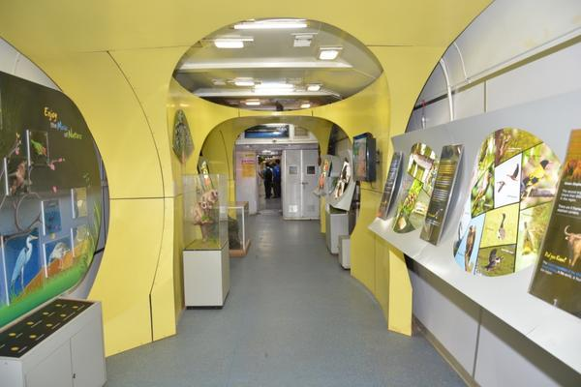
Coach 1 gave insights into greenhouse gases, its effects and the key message that human activities are the major cause for climate change. Coach 2 had panels of information on sea-level rise, monsoon variations and its effects on vital factors like water, forests, biodiversity and human health with the measures that can be taken to reduce these. This was just the beginning of the brilliance and innovation that the train held. Coaches 3 and 4 imparted knowledge about adapting to the environment, the eco-friendly strategies and options available in rural and urban areas and adaptation actions taking place across India.
As we moved further, we could see models of sea turtles, wild-life, nature all constructed beautifully. Coach 5 spoke about the concept of renewable energy and the emphasis on restoring the ecological balance by enhancing sinks and reducing toxic emissions through Renewable Energy (RE) techniques. Coach 6 had information on the various programs implemented by India for this purpose and its greater goal to reduce carbon footprint.
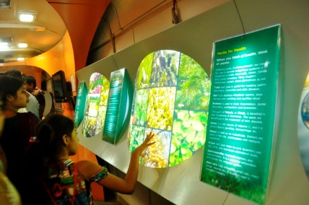
The 7th Coach had important highlights on the negotiations about climate change which had taken place internationally like UNFCCC, IPCC and the key outcomes of major COP also elaborating upon internationally agreed actions and targets. It also explained the concept of equity and common but differential responsibility. Coach 8 had interactive panels one what one can do in school, at their homes, at office with the focus being on improving lifestyle choices and spreading the message of, “Increase your Handprint, Decrease your Footprint.” They had ingeniously designed models which interested the attendees and helped them understand what they could do on an individual level to help reduce global climate damage.
Coaches 9 and 10 had exhibitions put up by the Department of Biotechnology and Government of India on themes like biotechnology for bio-resources and nature conservations, Tiger Conservation and Chemical Ecology and the country’s research and development initiatives in rapidly- rising field of Biotechnology. Coach 11 had exhibitions by National Innovation Foundation which showcased selected innovations, the ingenuity of common folks and a project which uses augmented reality techniques as well as covering themes like science education, DST Schemes, etc.
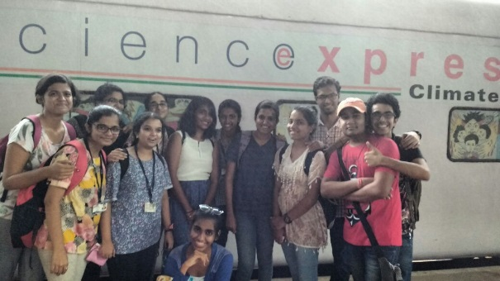
Coach 12 was a ‘Kids Zone’ set up for children from Std 4. And below so that they could participate in activities, games, solve puzzles on mathematics, science and environment. Coach 13 was JOS or ‘Joy of Science’, a hands-on-lab which was dedicated to students of Std 5-10 where they could perform various experiments to understand the complex concepts of science and environment in an engaging manner. Apart from this a training facility was set up to orient the teachers.

All in all, it was edutainment that the Science Express brought to Mumbai and is poised to spread education and awareness in every part of India as it has already and will halt at different railway stations across the country. We hope it is able to achieve its objectives.

LAKSHMI SIVARAMAN
TYBMM- JOURNALISM

